Iva’s Place… A Program Serving Victims of Domestic Violence
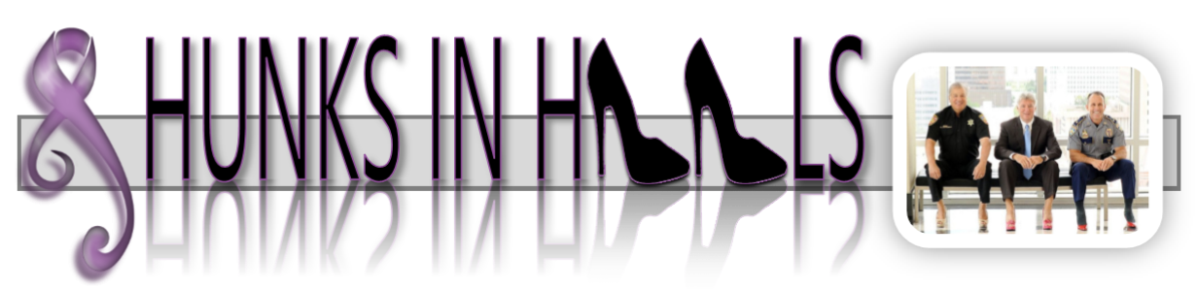
Put yourself in her shoes: It’s that critical decision making moment… Do you stay or do you go? If you go, where do you find shelter and safety? Each year the costs of operating a domestic violence Safe Haven Shelter increase. The Board Members of Iva’s Place are continually looking for ways to raise awareness in the community about the services we offer victims of domestic violence while raising the necessary funds to keep our Safe Haven Shelter in operation. The Hunks in Heels annual fundraising event is a playful opportunity for you to help raise awareness in our community about the serious causes, effects and remedies of domestic violence.
We want to thank you in advance for your willingness to not only “talk the talk” but, “walk the walk” and help break the silence and open the lines of communication about domestic violence.
Here are your next important steps
- Meet with the Kickoff Committee for your official calendar/website photoshoot August 15th 5-7pm. You will want to bring your shoes and props. Please remember to keep it classy and respectful of others, no cross dressing. *See attached chart and shopping locations. If you are walking in honor of someone, you may bring them along or a picture of them. We will shoot some group shots as well. We will have a make-up date for photos on August 25th 5-7pm. Please attend one of those photo shoots. The address for the photo shoot location is Southern Bell Events 102 E. Broadway St., Lenoir City, TN.

- Please complete the Bio’s and bring with you to the photoshoot or email them prior to the photo shoot to corrie@infuzion.com. *Form attached.

- Talk the Talk, launching September 6th, the Hunks in Heels website, will go live. Ask your friends, family, co-workers, etc to go to www.hunksinheelsTN.com and “vote” for you by making a donation. Each dollar raised online by you is equal to 1 vote bringing you that much closer to the coveted title of Mr. Hunks in Heels. All reservations and donations selected to go towards you will count towards your total.

- Shoe up and show up! October 6, 2022, is the grand finale and will be held at The Barn at Maple Creek in Kingston at 6pm! It’s your time to shine, we ask you to get dressed in your ensemble & shoes, enjoy dinner and our guest speaker, then it’s showtime! The emcee will read your brief Bio as you walk the runway to the music of your choice. This is your chance to rally the crowd and get them involved and cheer you on as you vie for the title of Mr. Attitude with Altitude! There will be 2 more impromptu fundraising moments; The Shoe Auction and Take a Picture with a Hunk. We will be auctioning off your shoes. Money from that auction will go toward your total.

- Last but not least, our special judging panel will award special recognition to two of our hunks; “Best in Shoe” and “Mr. Attitude with Altitude” and we will conclude the evening with the crowing in “Mr. Hunk in Heels” the #1 fundraiser of the year. Most importantly, you will forever have bragging rights as you were brave enough to “Shoe up, Speak up, and Step up”!
Thank you again for your willingness to support this important cause. Please reach out if you have any concerns or questions. Corrie Olson 865-254-6783.

Shoe Shopping made easy!
Local Shops that carry Womens Heels in Mens sizes are:
Marty & Liz 8079 Kingston Pike, Knoxville, TN 37919 (Olde Kingston Towne Shopping Center) DSW - Turkey Creek
Online: www.heelsforyou.com
There are many other sites and you can use the chart below to help you convert sizes.

Size Conversion Chart
There is an approximate 1.5-size difference between men's and women's sizing. A men's size 7 is roughly equivalent to a women's size 8.5.

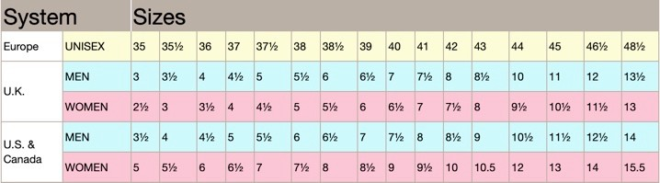

2022 Hunks in Heels Bio Sheet Please compete and bring to the Kick-off

Name:

Bio/Introduction:

Why are you walking:

Why should you vote for me as your 2022 Mr. Hunk in Heels?

Sample of your Bio/Introduction:
Name: Tim Watts

Bio/Introduction:

Tim is a Loudon County native. He works as a marketing rep for Caris Healthcare in Lenoir City, providing education to physicians, families, and the surrounding communities about hospice. He enjoys hiking, fishing, and traveling.

Why is Tim walking?

Having worked in different branches of healthcare I have encountered several instances of people who are unable to voice their concerns - because of fear of further abuse, physical impairment, or a feeling of neglect. I am here to be a voice and to show that every life matters regardless of race, gender, sexual orientation, age, or religious preferences. We are all equal - We stand to stop domestic violence.

Why should you vote for Tim as Mr. Hunk in Heels?

Have you seen the size of these heels?! Is there really a competition when somebody shows up in bright pink stilettos? Dolly, Madonna, and Audrey Hepburn would all be proud.

